Week 3

Q.1). Write a Python program to read a number and check whether it is even or odd.
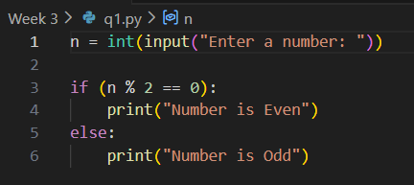
Output
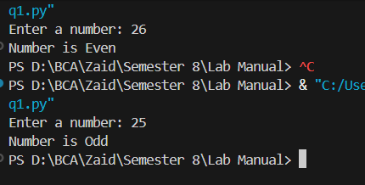
Q.2). Write a Python program to find the largest of three numbers using conditional statements.
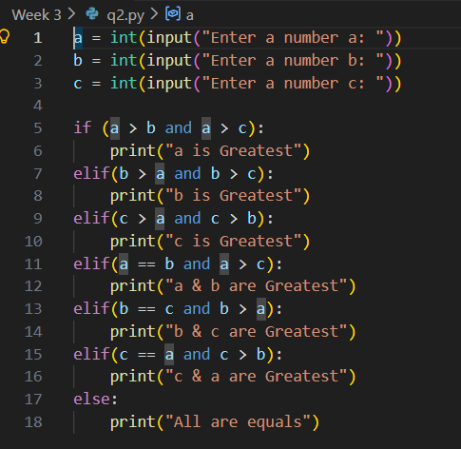
Output
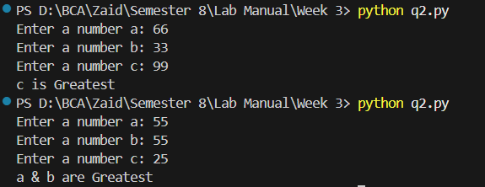
Q.3). Write a Python program to generate the first n Fibonacci numbers using a loop.
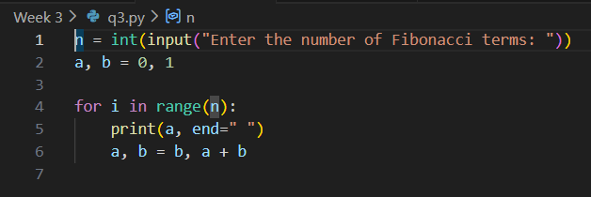
Output
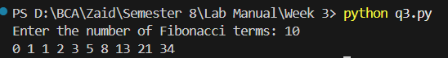
Q.4). Write a Python program to count the number of vowels in a given string.
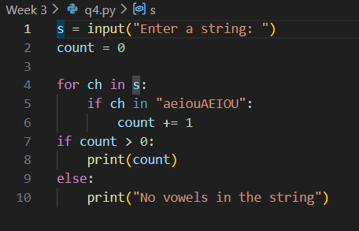
Output
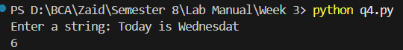
Q.5). 5. Create a HTML page with the following:
- Webpage Title “ My first web page”.
- Add BGCOLOR, TEXT attributes to the body.
- Show the use of different heading tags.
- Add two paragraphs to your webpage.
Show these text with following formatting along with line break:
- Italics – “This text is italics”
- Bold – “This text is bold”
- Underline – “This text is underline”.
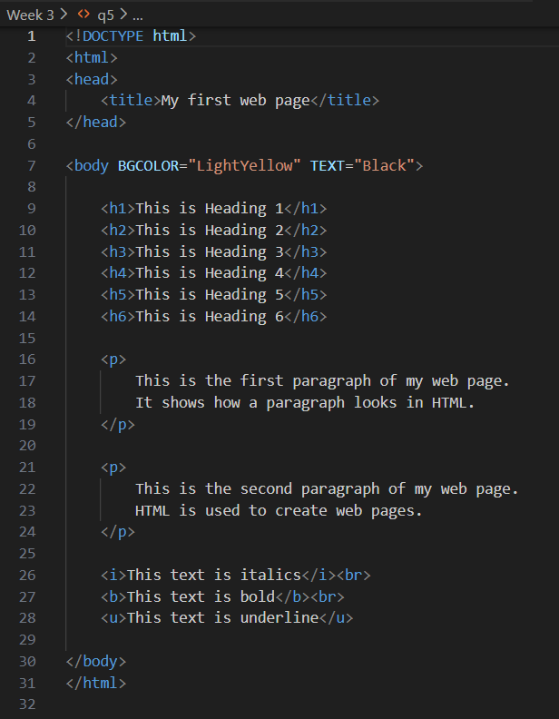

Output
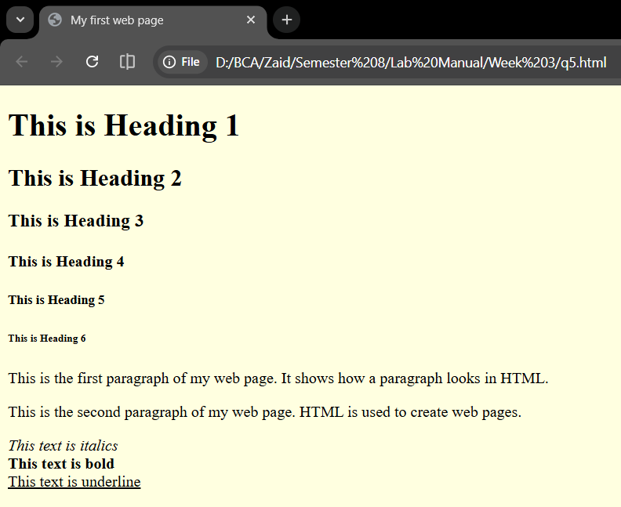

Q.6). Create a web page to show this output:
1. List of fruits:
- Apple
- Banana
- Guava
2. List of Vegetables:
- Carrot
- Cabbage
- Spinach
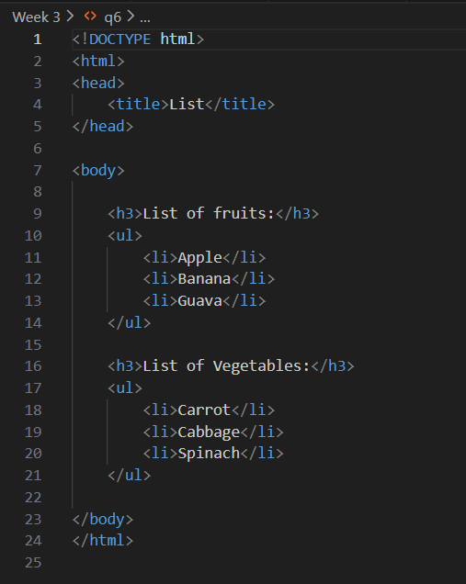

Output
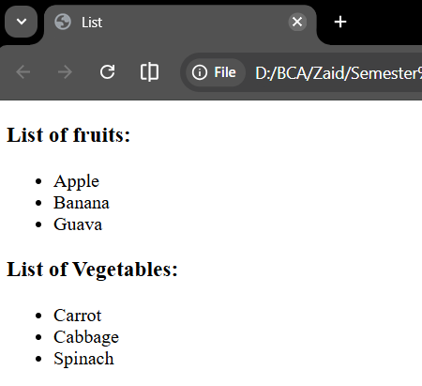

Q.7). Create the following table in HTML with Dummy Data:
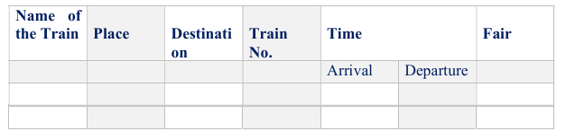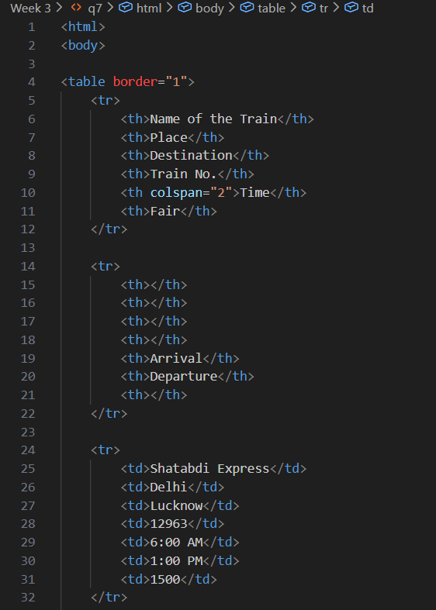
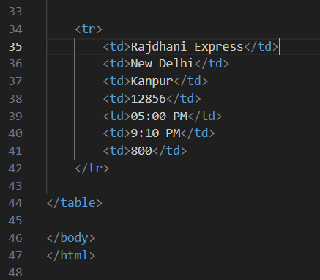
Output
